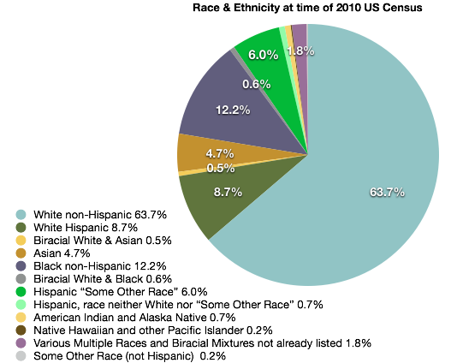
40 million persons living in the USA (out of about 310 million total population) were not born in the United States (about 13%).
11.3 million were born in Asia.
1-in-7 New U.S. Marriages is Interracial or Interethnic (14.6% of all marriages)
Among all newlyweds in 2008, 9% of whites, 16% of blacks, 26% of Hispanics and 31% of Asians married someone whose race or ethnicity was different from their own.
Most Americans say they approve of racial or ethnic intermarriage – not just in the abstract, but in their own families. More than six-in-ten say it “would be fine” with them if a family member told them they were going to marry someone from any of three major race/ethnic groups other than their own.
More than a third of adults (35%) say they have a family member who is married to someone of a different race. Blacks say this at higher rates than do whites; younger adults at higher rates than older adults; and Westerners at higher rates than people living in other regions of the country.
Immigration and Ethnicity
Facts about people living in America.

1
for video shown today, see www.historylines.net/Music/City_of_Immigrants.mov
for presentation slides, see http://www.historylines.net/lishi/2012/May_17.html
Eric Hadley-Ives
17 May, 2012

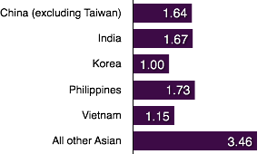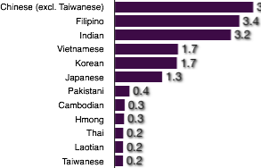
Between 2001 and 2010 these are the 40 nations which accounted for the most immigrants who received permanent residence. The numbers show how many people from each country received permanent resident status, or a “green card” from 2001 through 2010.
Where do recent immigrants come from?
Foreign-born persons in the United States who were born in Asia (in millions):
Estimates of undocumented immigrants
Ancestry / Ethnicity of persons identifying as being Asian or partly Asian in the 2010 Census (in millions):
2
1 | Mexico | 1,693,241
 | China (excluding Taiwan) | 662,678
 | India | 662,454
 | Philippines | 587,235
 | Dominican Republic | 329,133
 | Cuba | 318,391
 | Vietnam | 306,122
 | El Salvador | 252,829
 | Colombia | 251,316
 | Korea, South | 221,509
 | Haiti | 213,752
 | Jamaica | 180,715
 | Canada | 168,180
 | Guatemala | 160,675
 | Pakistan | 156,956
 | United Kingdom | 153,457
 | Ukraine | 149,292
 | Peru | 145,664
 | Russia | 139,720
 | Iran | 125,930
 | Brazil | 123,788
 | Poland | 116,824
 | Ecuador | 112,546
 | Nigeria | 111,212
 | Ethiopia | 109,732
 | Bangladesh | 106,740
 | Bosnia and Herzegovina | 89,000
 | Taiwan | 87,932
 | Venezuela | 84,391
 | Germany | 77,685
 | Guyana | 76,214
 | Japan | 76,050
 | Egypt | 73,087
 | Thailand | 68,303
 | Honduras | 65,386
 | Ghana | 65,331
 | Iraq | 65,022
 | Somalia | 64,150
 | Trinidad and Tobago | 61,757
 | Nicaragua | 60,878
Mexico | 6,640,000
El Salvador | 620,000
Guatemala | 520,000
Honduras | 330,000
Philippines | 280,000
India | 200,000
Ecuador | 180,000
Brazil | 180,000
Korea | 170,000
China | 130,000
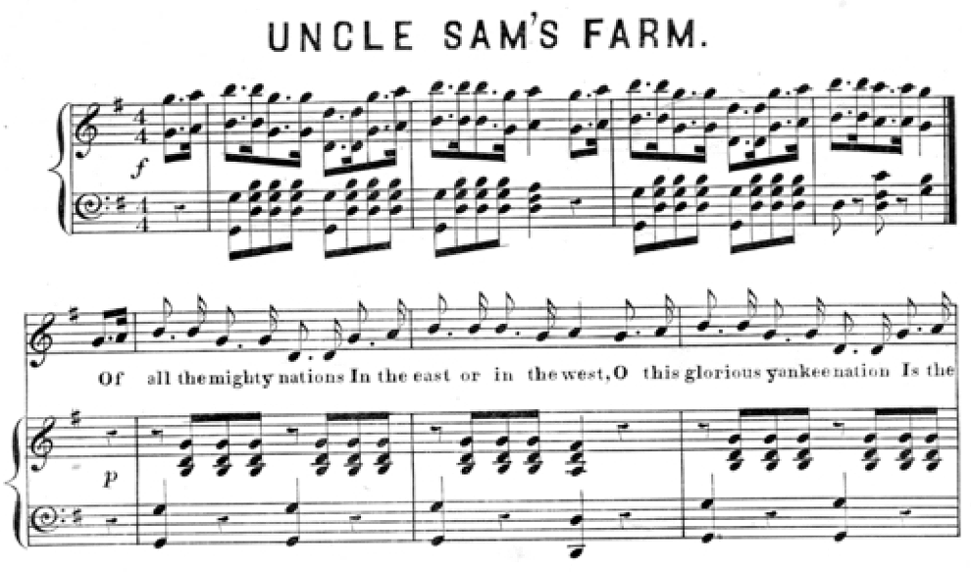
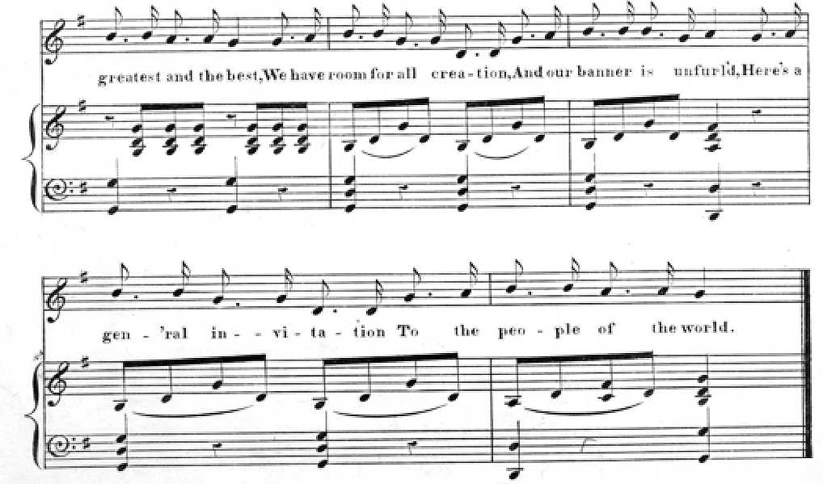
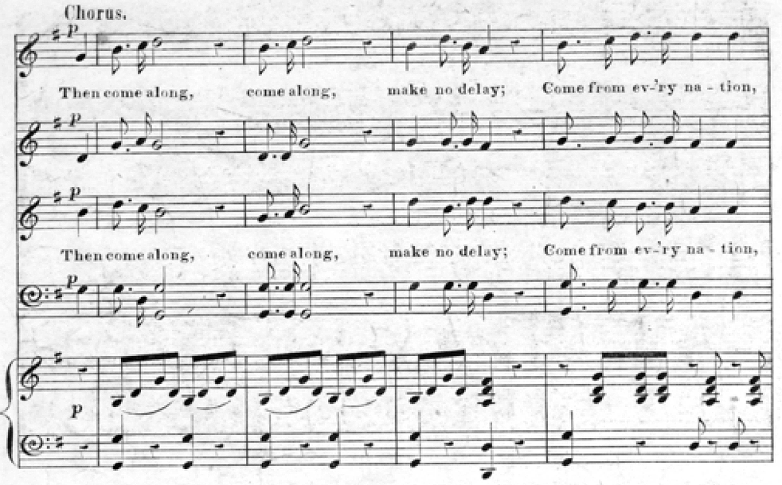
The inclusive and open tradition in the United States:

Open to immigration.

Freedom for people of many political and religious traditions.

Anti-slavery and abolition movements.

Advocates and allies of American Indians, Chinese and Mexican immigrants, freedmen, and runaway slaves.

Anti-Imperialist League and opposition to imperialism.

Civil Rights Movement and national effort to attack racism and racist institutions.

Court decisions to give equal rights to all. A tradition that all are equal before the law.

Enlarging rights and inclusion to persons with disabilities, sexual minorities, etc.

American activists for peace and the international anti-war movements.

Opening the country to refugees.

Aid for international development and widespread public charitable giving.

Rapid social changes between 1960-2010 to accept interracial relations, with a steep decrease in measured ethnocentric attitudes.

Rapid changes in attitudes toward opponents in wars (quickly forgive and forget).

Nationality based on geography and ideals rather than ethnicity or race. There is no “American ethnicity” or race.
3
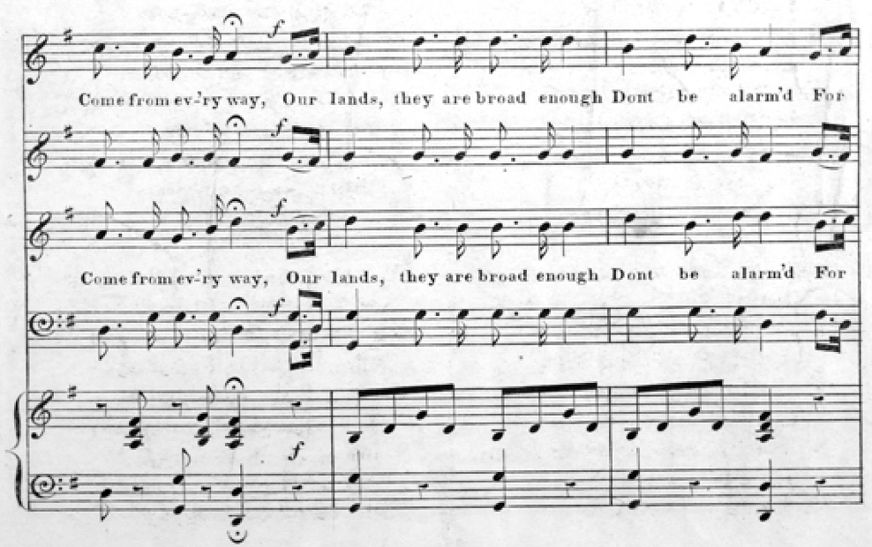
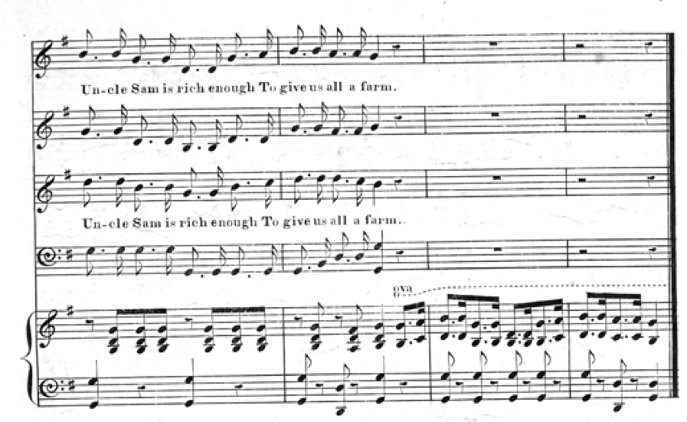
The exclusive and prejudiced tradition in the United States:

Racism.

Racist organizations and ideologies, including the Ku Klux Klan, the Democratic Party of the 1800s, the Know-Nothings, etc.

Nativist opposition to immigration and immigrants based on ideals about ethnicity or ideal racial proportions.

Genocidal wars against American Indians and long-term oppression of Indians.

Slavery and the system of oppression and intimidation against Freedmen and African-Americans that followed slavery.

Violent pogroms and mob action against non-European-American populations. Lynching.

Imperialism (Philippines) and support for terrorists or brutal dictatorships, especially in Latin America.

Wars of territorial expansion against Mexico and Indian Nations. Dehumanization of enemies during wars.

Invention of Total War making civilians targets in warfare.

Discriminatory laws against non-European-Americans, including the 1882 Chinese Exclusion Act.

Foreign aid is the least popular government program; the only specific program a (very slight) majority of Americans want to cut.

Laws to intimidate and harass residents without documentation or legal status; these laws allow or force unfair treatment of non-European-Americans.

Continuing discrimination and prejudices against persons of other ethnicities.

Milestones in American ethnic history.
1848-49. Unrest in Europe and Gold Rush in California attracts masses of immigrants, refugees, and workers from Europe and Asia.
1861-1865. War of the Rebellion of the Southern Slaveholders (Civil war). Racism and Slavery are at the root of the war.
1860s. Emancipation Proclamation, 13th and 14th Amendments to the Constitution (abolish slavery, make African-Americans citizens with full rights), 1866 Civil Rights Law, establishment of Freedmen’s Bureau, military occupation of southern states.
1880-1920 Mass immigration from Europe beyond the British Isles
1882 Chinese Exclusion Act.
1890s-1940s: Nadir of Race Relations
1924 Immigration Act (quotas). American Indians become citizens.
1965 The Immigration and Naturalization Act of 1965.
1970-2010 Mass immigration, especially from Mexico, Latin America, and Asia. Over 10 million immigrants each decade after 1990.

4
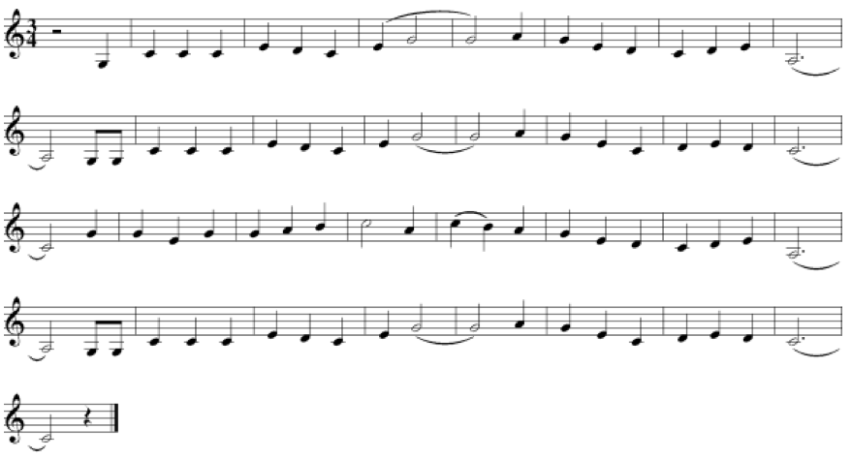
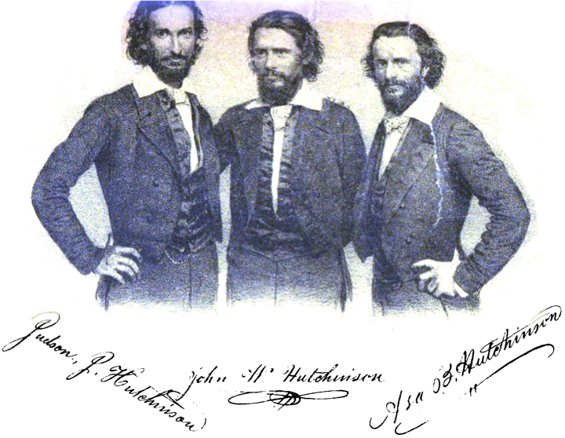
Uncle Sam’s Farm (before 1853s) (by Jesse Hutchinson Jr.)
Of all the mighty nations in the East or in the West,
O this glorious Yankee nation is the greatest and the best.
We have room for all creation and our banner is unfurled,
Here's a general invitation to the people of the world.
Chorus:
Then come along, come along, make no delay;
Come from every nation, come from every way.
Our lands, they are broad enough - don't be alarmed,
For Uncle Sam is rich enough to give us all a farm.
St. Lawrence marks our Northern line as fast her waters flow;
And the Rio Grande our Southern bound, way down to Mexico
From the great Atlantic Ocean where the sun begins to dawn,
We’ll cross the Rocky Mountains far away to Oregon.
[Chorus]
While the South shall raise the cotton, and the West, the corn and pork,
New England manufactories shall do up the finer work;
For the deep and flowing waterfalls that course along our hills
Are just the thing for washing sheep and driving cotton mills.
[Chorus]
Our fathers gave us liberty, but little did they dream
The grand results that pour along this mighty age of steam;
For our mountains, lakes and rivers are all a blaze of fire,
And we send our news by lightning on the telegraphic wires.
[Chorus]
While Europe’s in commotion, and her monarchs in a fret
We’re teaching them a lesson which they never can forget;
And this they fast are learning, Uncle Sam is not a fool,
For the people do their voting, and the children go to school.
[Chorus]
The brave in every nation are joining heart and hand
And flocking to America, the real promised land;
And Uncle Sam stands ready with a child upon each arm
To give them all a welcome to a lot upon his farm.
[Chorus]
A welcome, warm and hearty, do we give the sons of toil
To come to the West and settle and labor on free soil;
We've room enough and land enough, they needn't feel alarm -
O! come to the land of freedom and vote yourself a farm.
[Chorus]
Yes! we're bound to lead the nations for our motto's "Go ahead,"
And we'll tell the foreign paupers that our people are well fed;
No monopoly of Kings and Queens, but this is the Yankee plan,
Free Trade to Emigration and Protection unto man.
[Verse added in 1860]
We've a glorious Declaration To protect us in our rights,
An instrument of Freedom, For the blacks as well as whites,
And the day is swiftly coming When Liberty's bright sun
Shall shine with noonday splendor In the land of Washington.
Lincoln and Liberty and
The Liberty Ball (1860)

Hurrah for the choice of the nation,
Our chieftain so brave and so true,
We'll go for the great reformation,
For Lincoln and Liberty, too!

We'll go for the son of Kentucky
The hero of Hoosierdom through,
The pride of the "Suckers" so lucky,
For Lincoln and Liberty, too!

They'll find what by felling and mauling,
Our railmaker statesman can do;
For the people are everywhere calling
For Lincoln and Liberty too.

Then up with the banner so glorious,
The star-spangled red, white, and blue,
We'll fight till our banner's victorious,
For Lincoln and Liberty, too.

Our David's good sling is unerring,
The Slavocrat's giant he slew,
Then shout for the freedom preferring,
For Lincoln and Liberty, too.

We'll go for the son of Kentucky, etc.

Come all ye true friends of the nation
Attend to Humanity's call;
Come aid in the slaves' liberation
And roll on the Liberty Ball.

And roll on the Liberty Ball
And roll on the Liberty Ball;
Come aid in the slaves' liberation
And roll on the Liberty Ball.

We're foes unto wrong and oppression,
No matter which side of the sea;
And ever intend to oppose them
Till all of God's creatures are free.

Till all of God's creatures are free etc.

We'll finish the Temple of Freedom
And make it capacious within,
And all who seek shelter may find it
Whatever the hue of their skin.

Whatever the hue of their skin etc.

Success to the old-fashioned doctrine,
That men are created all free;
And down with the power of the despot
Wherever his strongholds may be.

Wherever his strongholds may be etc.

The liberty hosts are advancing,
For freedom to all, they declare;
The downtrodden millions are sighing
Come break up our gloom of despair.

Come break up our gloom of despair etc.
5
Questions to discuss with a partner in the middle portion of the presentation.

If culture is socially-constructed: if it is a set of attitudes, behaviors, personality tendencies, and habits, then to what degree can someone “have a culture” when they are born? If a child is adopted away from one culture and into another, does the child in some way belong to the culture of their origin?
Can an European or African have Chinese culture? Can a Chinese person have African or European culture? Can one American be “more American” than another one?
Some people share transnational interests or habits. For example, in the community of scholars, experts in literature share habits, training, skills, and interests no matter what their culture of origin, and so do medical doctors, chemists, engineers, social workers, and so on. In global popular culture, people all over the world love the same specific famous sports teams or movie stars or musicians. Certain foods are popular across cultures. How can these trans-national cultures compare to national cultures or ethnic cultures? Does a person have their national culture diminished or weakened when they embrace aspects of culture that are from outside their culture?
What do we mean when we say that someone is a foreigner? How we distinguish between someone who is “one of us” and someone who is not?
What do we personally gain by having our nationality as part of our identity? How is it helpful to us to “be Chinese” or “be American” as we try to meet our needs as human beings? Is it strange to dislike one’s own culture, or to be highly attracted to another culture? How can a person be alienated from their own culture?
Some visionaries have proposed that humanity should do away with restrictions on movement across borders, so that anyone could go to any country they liked. Do you think that in the long-run, in the future, this is a desirable situation? Imagine a world without passports or border controls or immigration laws. In what ways could this be a good thing, and what problems would it pose for us?
The United States has traditions of humanitarianism and unprejudiced openness to all people, and it also has traditions of racism and prejudice and violent ethnocentrism. How do you explain how two such contradictory attitudes and value-systems could both be part of a national culture as in the USA? Can you think of similar contradictory Chinese traditions? Consider, are there good examples of Chinese people being friendly and welcoming to foreign visitors and also contradictory examples when Chinese people have been full of prejudice, xenophobia, or racism?
How would you feel about dating or marrying someone from Africa, India, the Middle East, Europe, the Americas, or the Pacific Islands? Do you have different feelings about people from different regions? What about Koreans, Japanese, Tibetans, Vietnamese, Mongolians, or other East Asians? Would it be easier to form a household or life-long partnership with a Han Chinese, and ethnic minority Chinese, an East Asian, or someone with a more exotic background from further away?
Can you think of a situation when your brain went into the “us against them” sort of “out-group versus in-group” mentality, when you were angry at a group of people? How did it happen? Did you recognize what had happened? What did you do about it?

6

